**ATTENTION POTHOLES !!!**

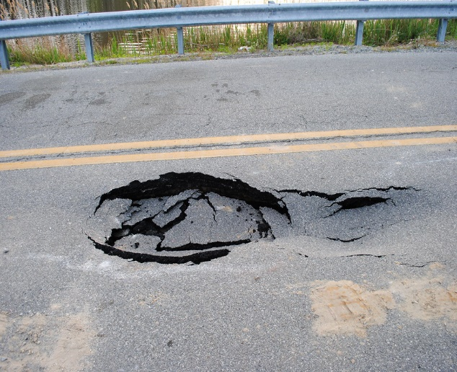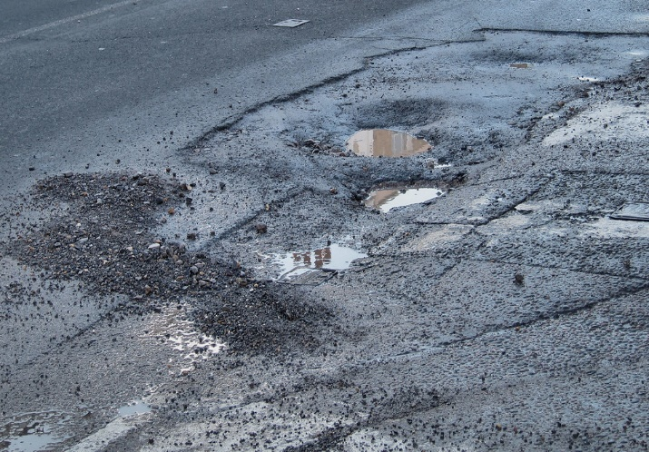

Tired of seeing the state of the roads and paths around the parish in disrepair, worried about accidents waiting to happen - then please look at reporting any problems with potholes….

A new website for reporting issues with portholes has launched and can be accessed at :

[www.fillthathole.org.uk](http://www.fillthathole.org.uk)

Many Thanks on behalf of the Foston Parish Council